**CST-239 Activity 2**

**Aug 26,2023**

**Taofik Otiotio**

**Part 1: Superhero Battle**

1. **Theory Of Operation Write-ups**

A Java program simulates Superman and Batman fighting. The Game class creates superheroes and loops until one is defeated. Both superheroes start with random health values. Debugging messages appear when Superman and Batman instances are created with these health values.

If Superman and Batman survive, the battle loop drives the simulation. Each iteration, both superheroes switch attacks. The attacker's attack method generates a random damage value between 1 and 10 that determines Health applies to the opponent's health. Debugging messages show the attacker's name, damage, and opponent's health after an attack.

After each attack, the program checks if either superhero's health drops below zero, indicating defeat. This simulation shows class inheritance, method overriding, and the flow of a simple game-like program.

1. **Run The Game And Take A Screenshot Of The Game Results.**

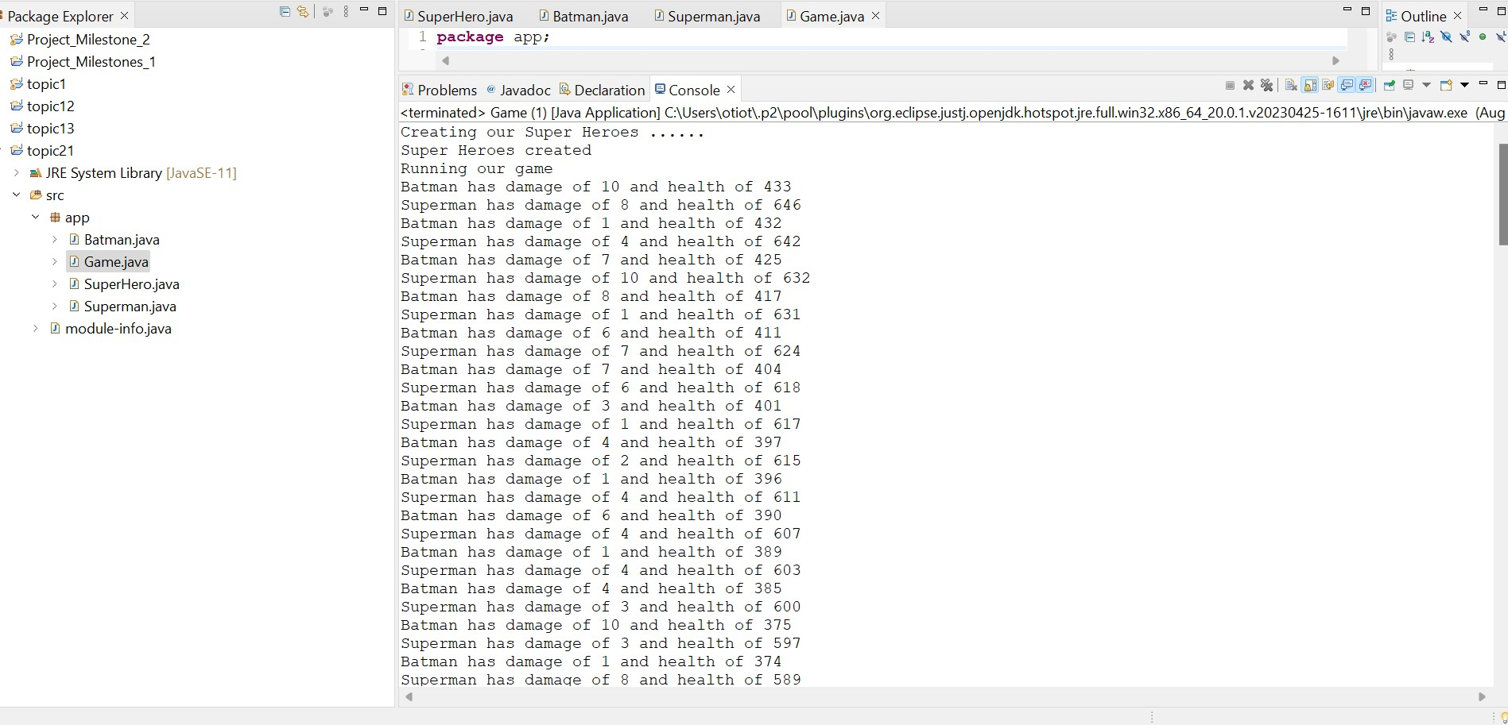

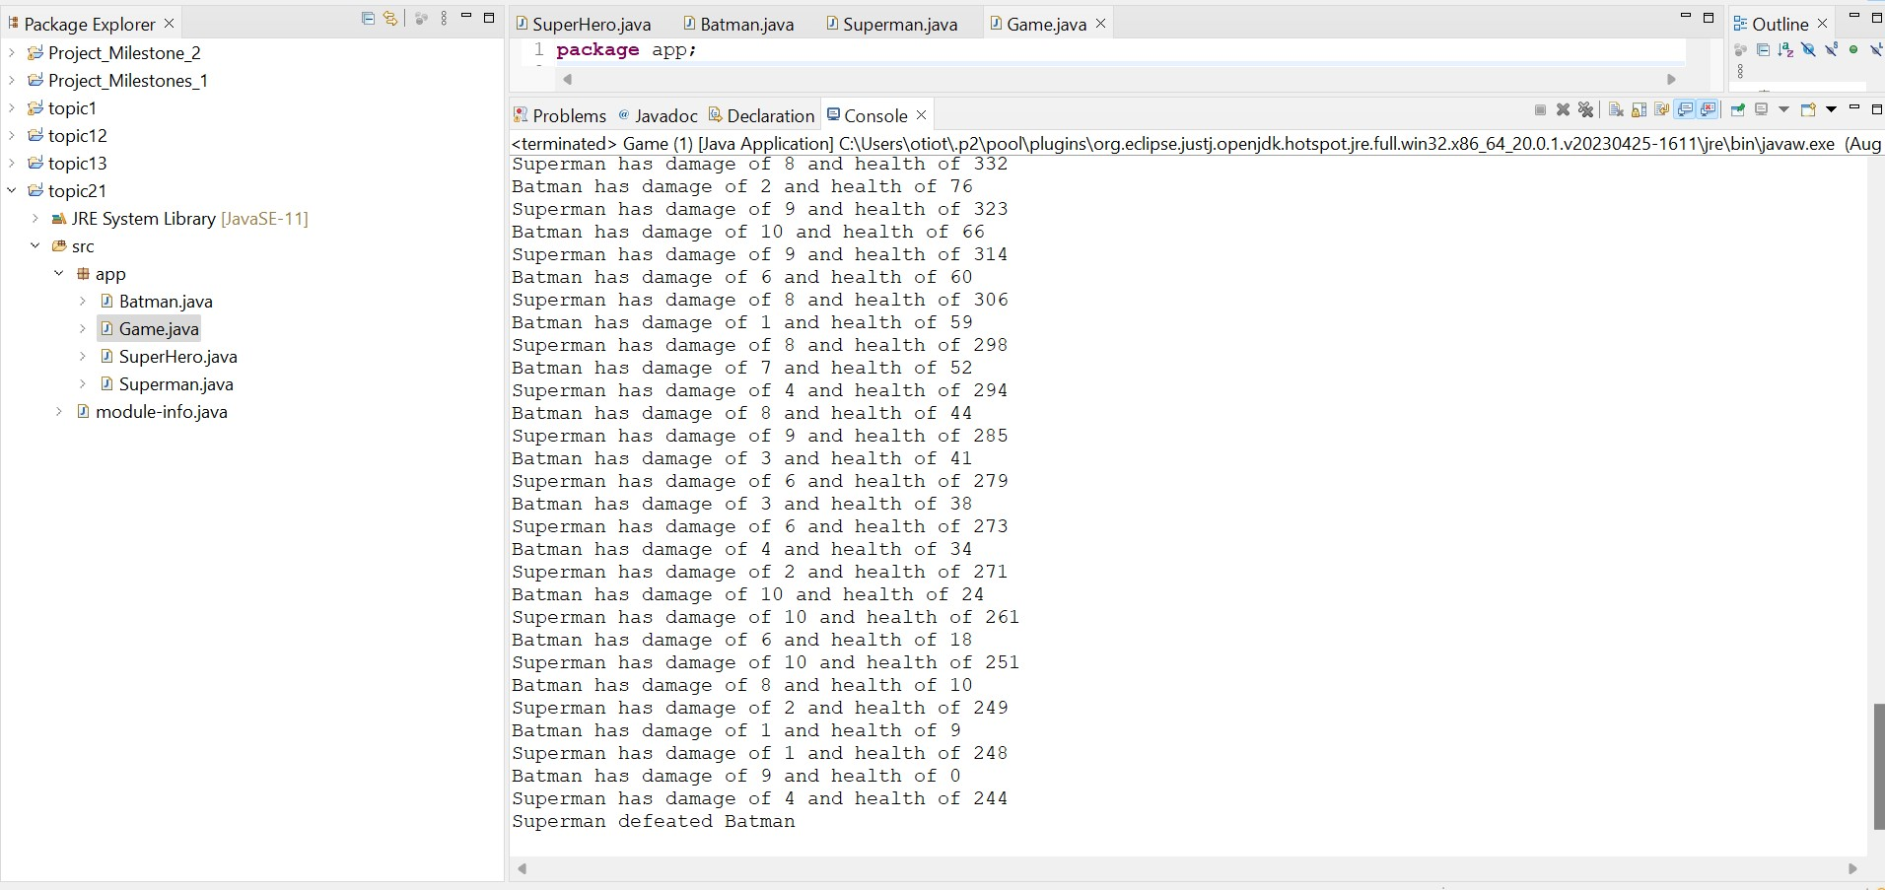

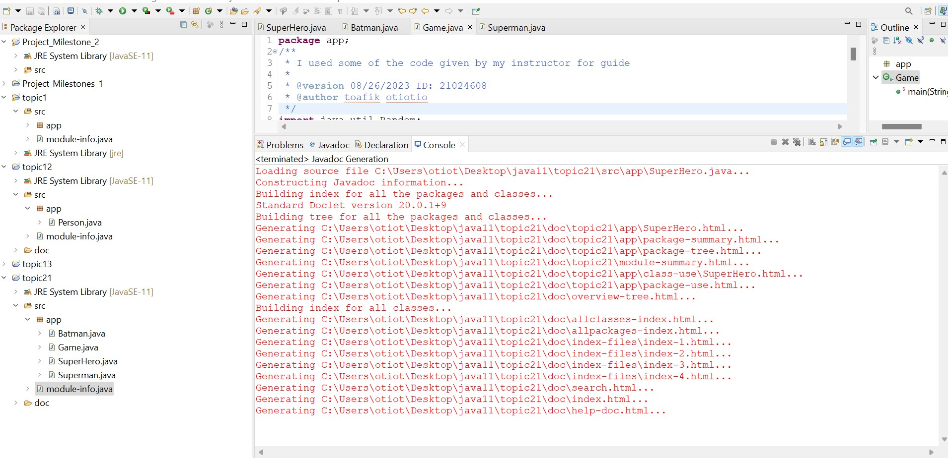

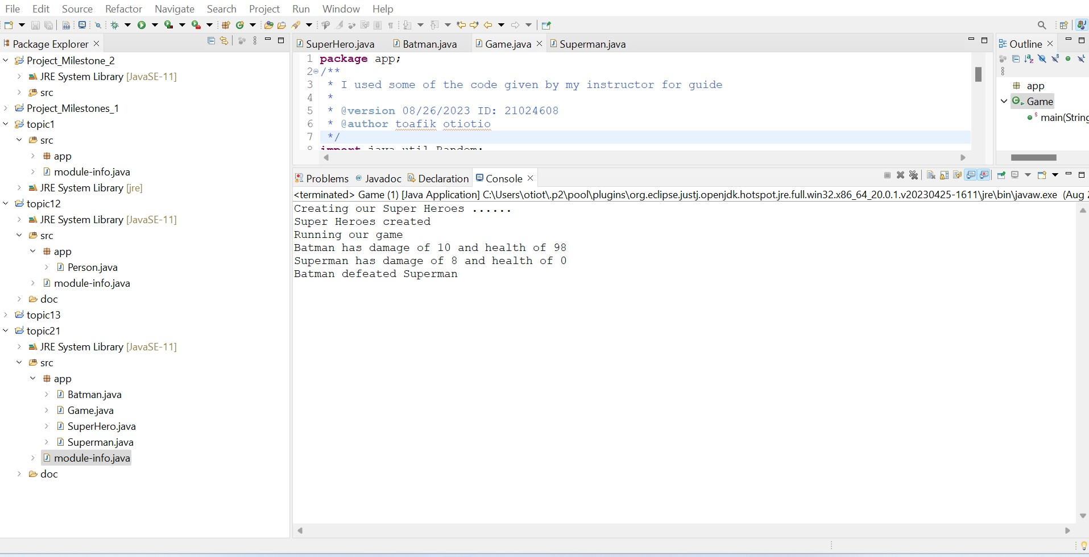

**Description Of How And Why The Output Was Displayed**.

The program makes it look like Superman and Batman are fighting, with random health values between 1 and 1000. They attack each other, and the program shows what they did, how much damage they did, and how much health they have left. If either superhero's health drops to zero, the loop ends and the program prints out whether Batman beat Superman or Superman beat Batman, depending on who won.

**Part 2: Weapans, Bombs, And Guns**

**Theory Of Operation:**

**Weapon**

The **Weapon** class is an abstract representation of a generalized weapon, providing common functionalities and serving as a blueprint for specific weapon types. At its core, every weapon has the ability to be activated or deactivated using the **activate()** method, and to be fired with a specific power using the **fireWeapon(int power)** method. The exact behaviors of these methods may vary between weapon types, hence the use of abstract methods to ensure implementation by subclasses. The class uses reflection and stack trace techniques to fetch class and method names, ensuring dynamic understanding of which weapon and method are in operation.

**Bomb**

A subclass of **Weapon**, the **Bomb** class represents explosive devices. Like other weapons, a bomb can be activated or deactivated. When fired using the **fireWeapon()** methods, it displays details like its class name, method name, and the power it's triggered with. The class offers an overloaded version of the **fireWeapon()** method, which uses a default power value of 10. Using reflection and stack trace techniques, the Bomb class provides real-time information about its state and actions.

**Gun**

The Gun class, another descendant of Weapon, characterizes firearms. The Gun can be fired using the fireWeapon() methods, which display its class name, method name, and the power with which it was discharged. It also provides an overloaded fireWeapon() method that defaults to a power of 5. The activate() method allows users to toggle the gun's active state. While the Gun class has its unique behaviors, it leverages common functionalities from its superclass, Weapon.

**Game**

The Game class orchestrates the simulation, instantiating both Bomb and Gun objects and demonstrating their functionalities. Within the main method, it showcases the weapon activation and firing functionalities, calling both the primary and overloaded fireWeapon() methods. This class gives a practical demonstration of how the weapon classes and their methods can be used in a real-world application.

**Create A Game Class**

**Run The Game And Take A Screenshot Of The Output**.

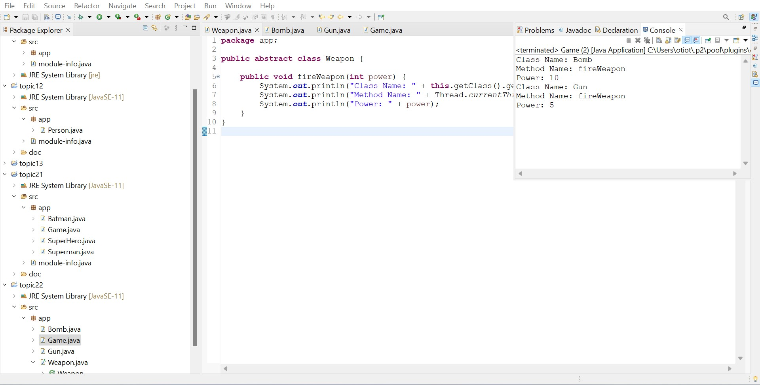

**Description Of How And Why The Output Was Displayed.**

The output was shown because the FireWeapon method was called on Bomb and Gun classes in the Game class. This method prints out the class name, method name, and power value. The Bomb and Gun classes, which extend the Weapon class, use the Weapon class's implementation. This is why the output shows class names, method names, and power values.

4. **Override Method**

**Run The Game And Take A Screenshot Of The Output.**

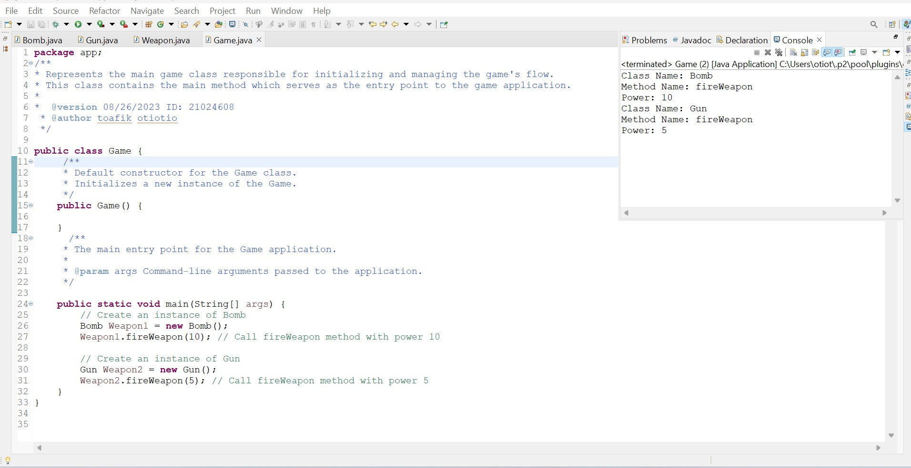

**Description of how and why the output was displayed**

The output displays the details of the weapon fired and its power, as both Bomb and Gun classes override the fireWeapon method from the Weapon superclass. The overridden method prints the class name, method name, and power value. The Game class's main method creates instances of both classes and invokes their fireWeapon methods.

**5.. Overload Method**

**Run the Game that fires each weapon using the fireWeapon() and the fireWeapon(power). A screenshot of the output.**

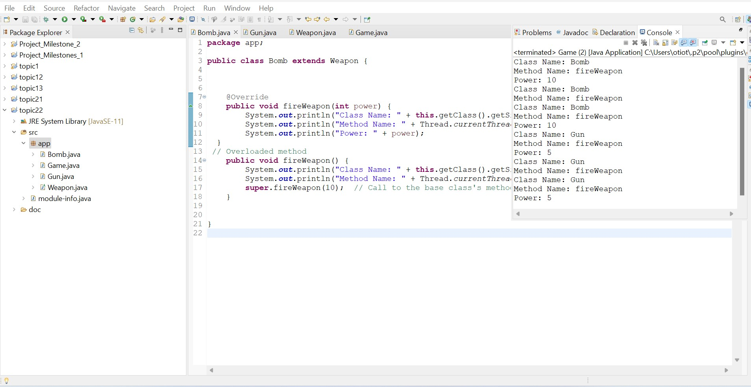

**Description of how and why the output was displayed.**

When the fireWeapon methods in the Bomb and Gun classes are activated, the resulting output emerges. Each invocation of these methods prints the class's name, the method's name, and any provided power value. The class and method names are ascertained through reflection and stack trace methods. The power value is either specified directly or, in the case of the method without parameters, obtained by invoking the fireWeapon method from the superclass Weapon.

**6. Abstract Method:**

**Run the Game that activates each weapon then fires each weapon using the fireWeapon() and the fireWeapon(power). A screenshot of the output.**

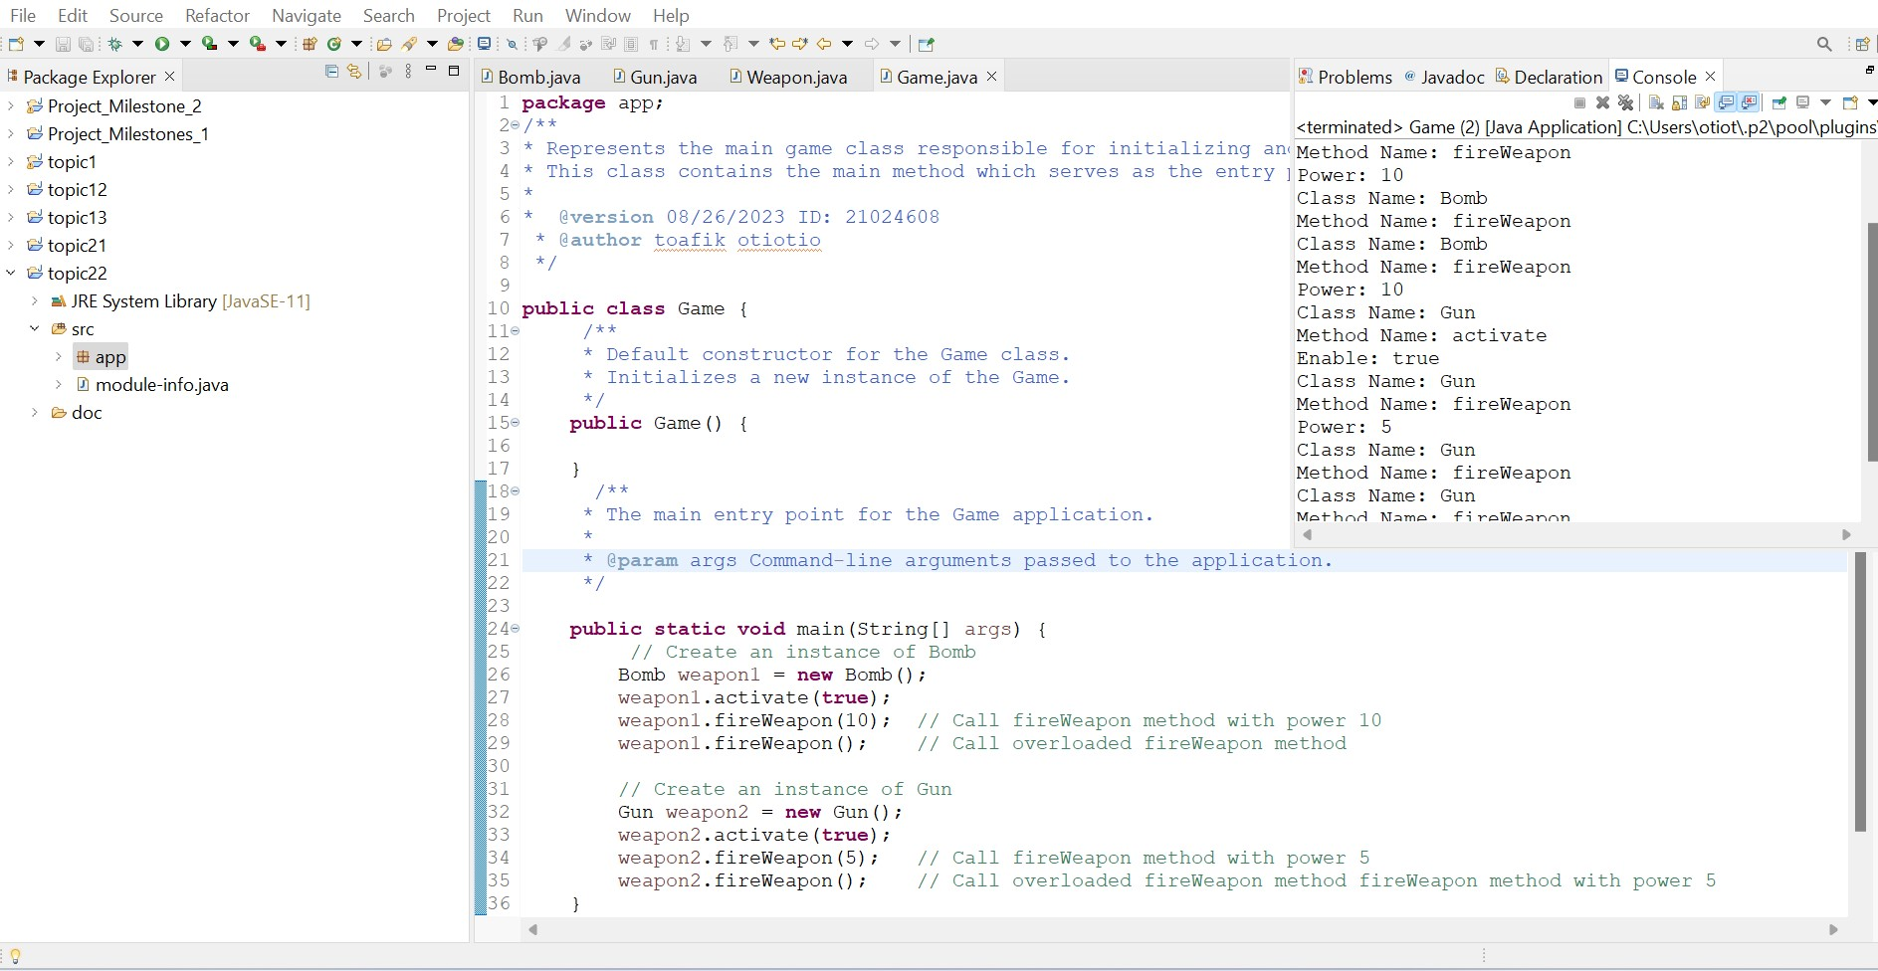

**A screenshot of the Weapon, Bomb, and Gun classes implementation code.**

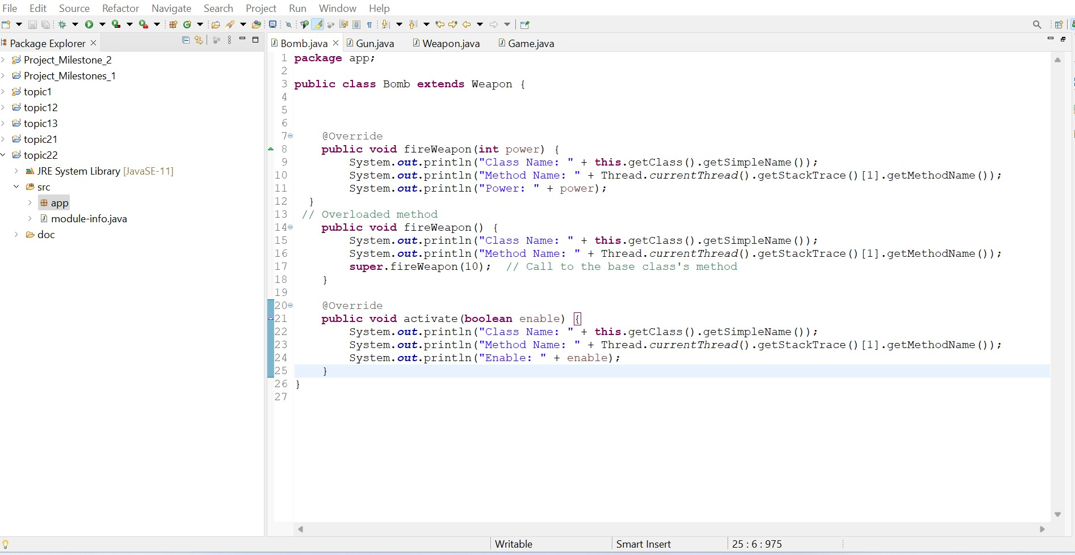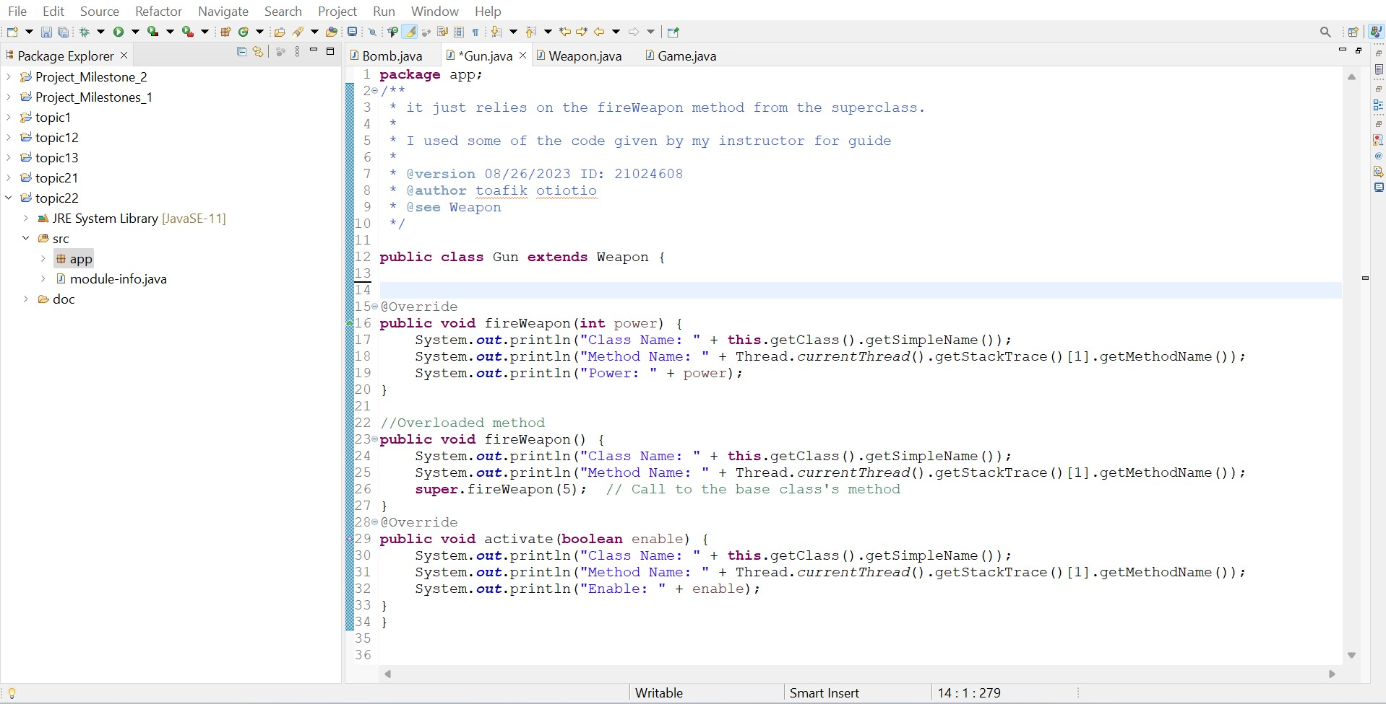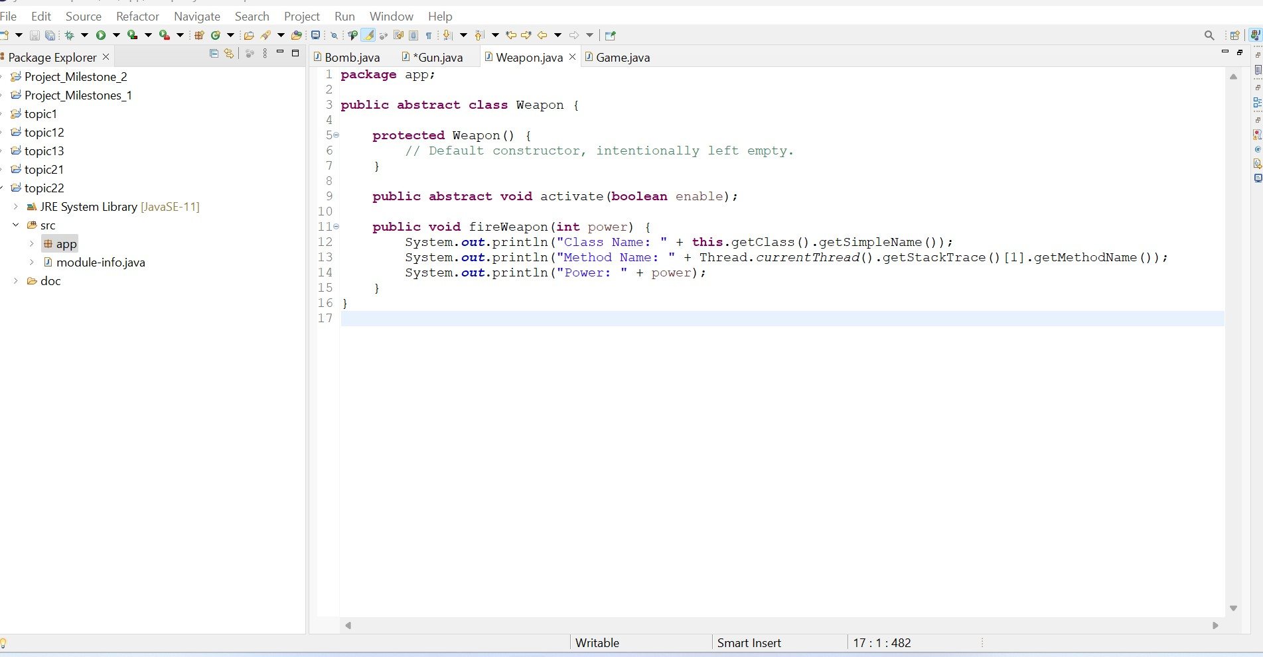

**7. Additional Tests:**

**A. Make the Weapon class final. A screenshot of the compiler error is displayed below.**

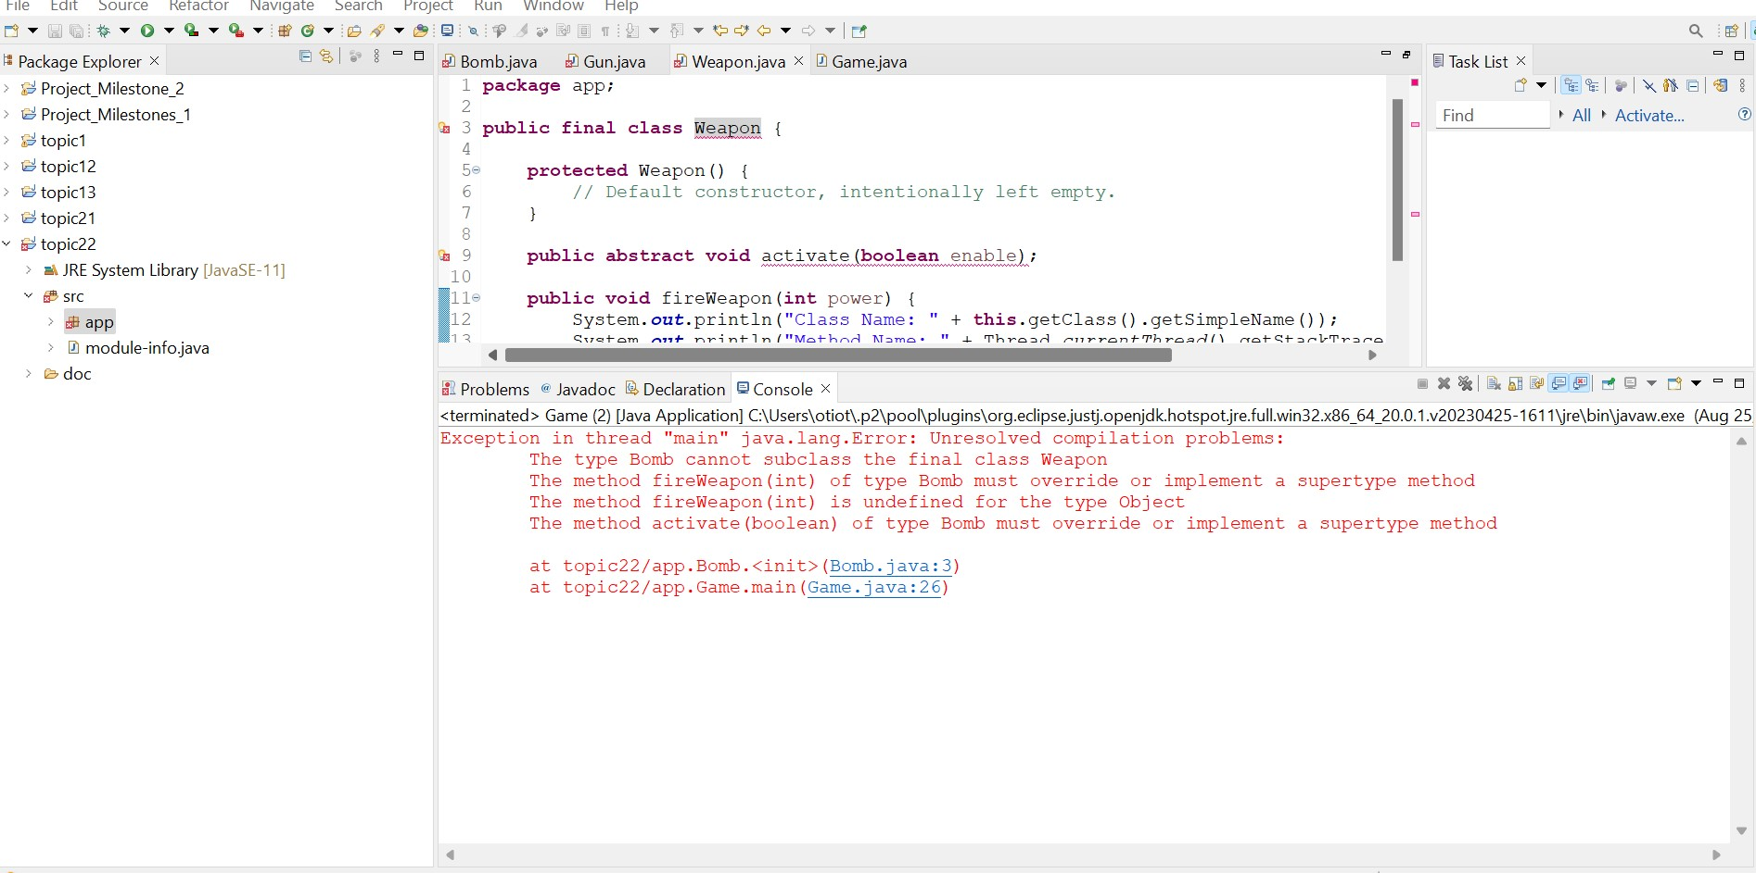

**Why did the error occur?**

This error happens because the keyword "final" means that a class cannot be subclassed, which means that no other class can build on it. The point of making a class "final" is to stop it from being inherited. Since Bomb and Gun are trying to extend the Weapon class, which is now complete, the Java compiler throws an error to stop them.

**B. Change the fireWeapon() method in the Weapon class to final and not abstract. A screenshot of the compiler error that is displayed**

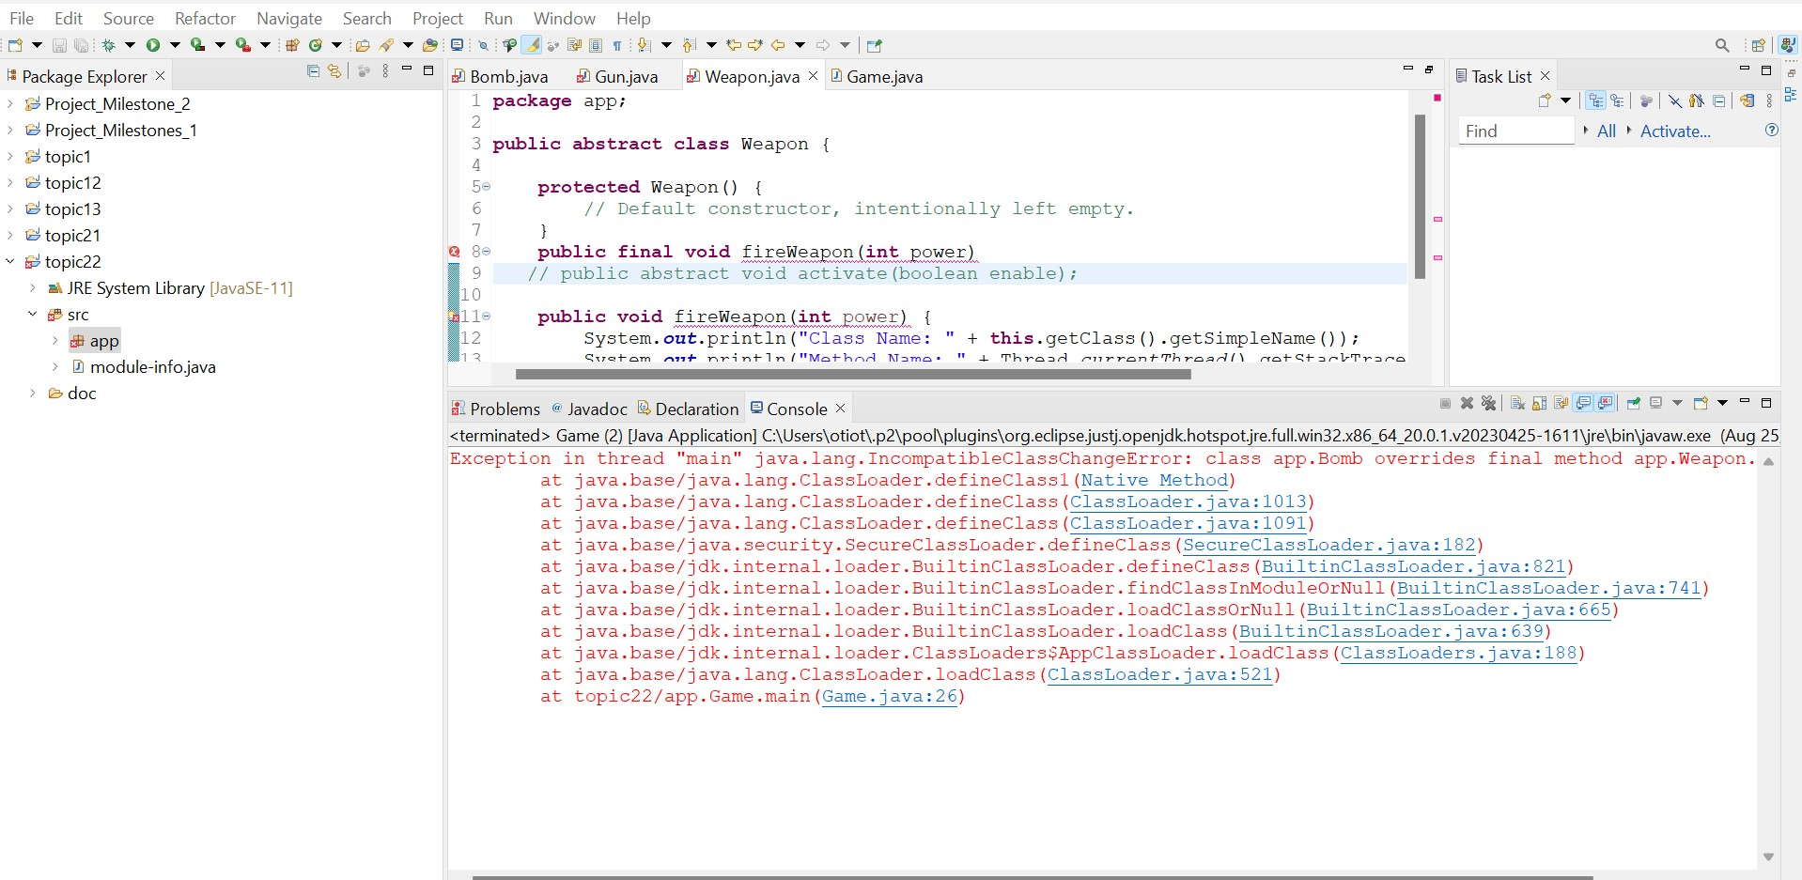

**Why did the error occur?**

This error happens because when the final keyword is used on a method, it means that no subclasses can change this method. In this case, the Java compiler throws an error because the Bomb and Gun classes are trying to override a method that is now marked as final.

**C. Change the fireWeapon() method in the Weapon class to abstract and not final. A screenshot of the compiler error that is displayed.**

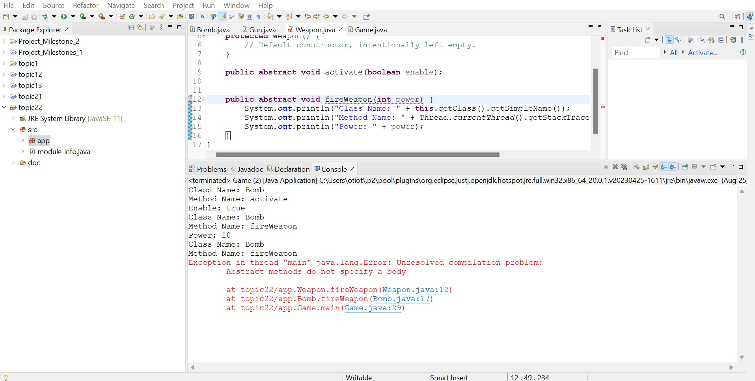

**Why did the error occur?**

This error is shown because neither the Bomb class nor the Gun class implemented the abstract method fireWeapon(int). Any non-abstract class that extends an abstract class must implement all of the abstract methods of the class it extends.

**Part 3: How to Compare Person Objects**

**Theory of operation write-ups**

There are two classes in the app package. They are Test and Person. The firstName and lastName attributes of the Person class describe a person. It has a standard constructor, a copy constructor, and getter methods for its attributes. The equals and toString methods of the class have been changed so that they can be used for custom comparisons and string representations. The Test class shows how to make Person objects, compares them using both the == operator and the equals method, and then shows the objects using the toString method.

**Run The Test Class. A Screenshot Of The Output.**

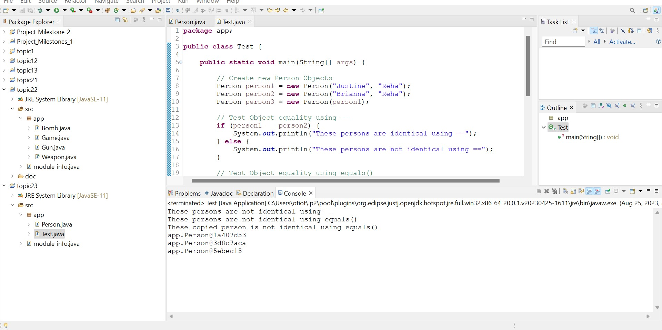

**Description Of How And Why The Output Was Displayed.**

The main method tests the equality of Person objects (person1 and person2) and a copied object (person3) in the Person class. The == operator indicates that person1 and person2 are not the same object due to their different memory locations. The equals() method in the Person class is likely not properly overridden to check for content equality, as both checks indicate they are not identical. The final three outputs reveal that the three Person objects are indeed different objects in memory.

**5. Final Test:**

**Run the Test class. A screenshot of the output.**

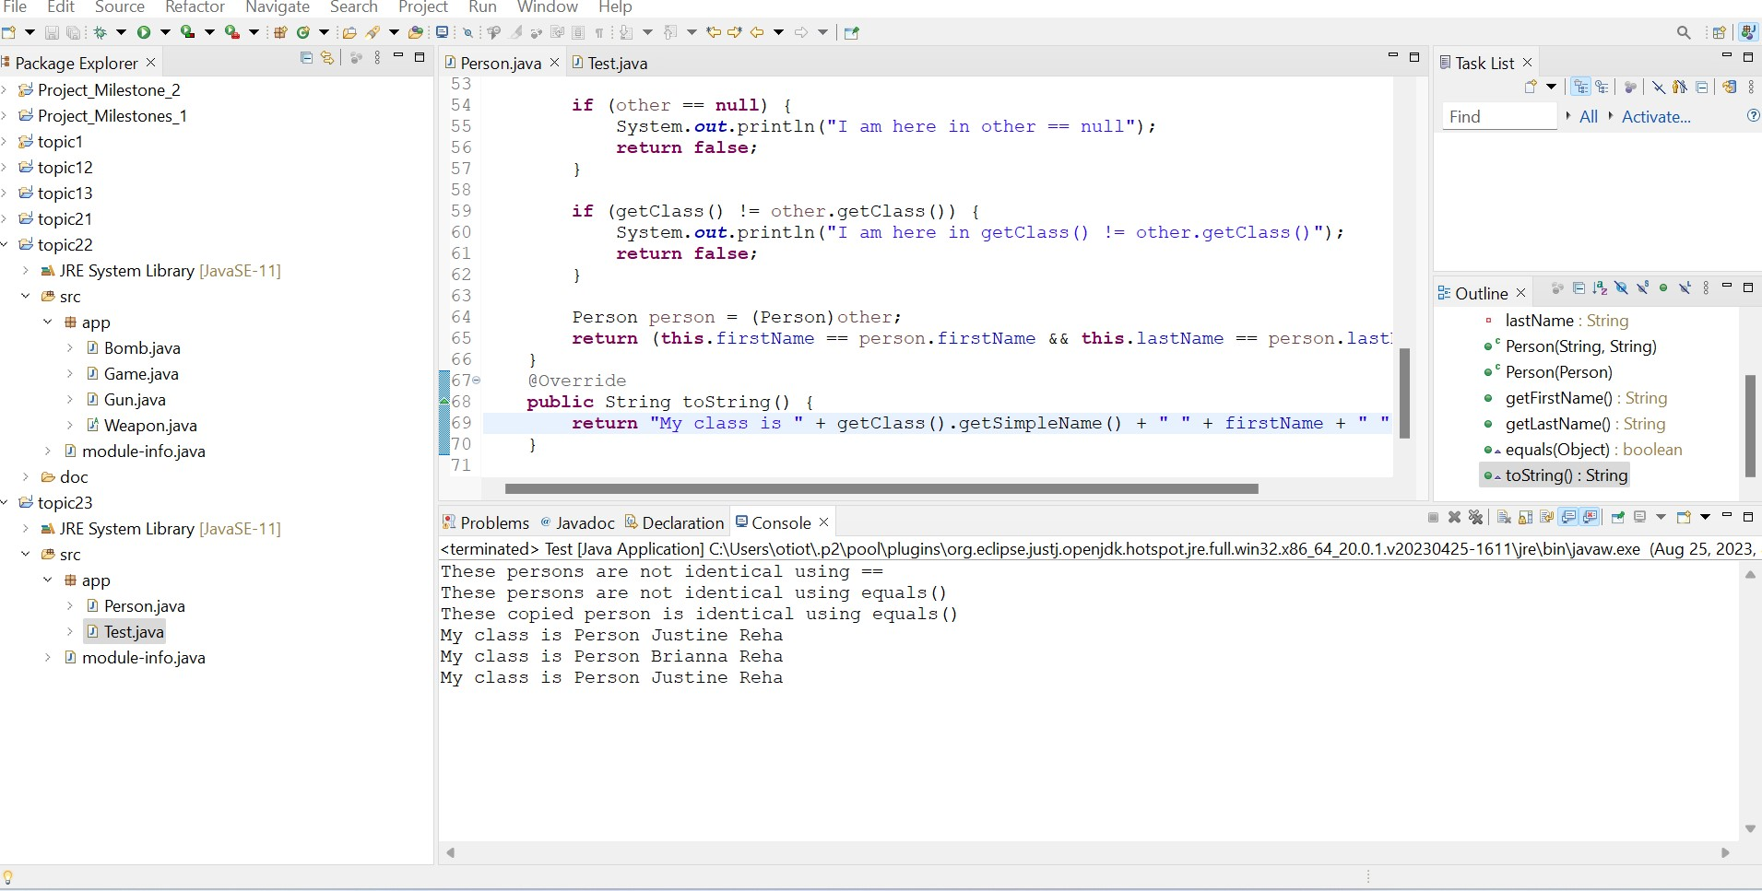

**Description Of How And Why The Output Was Displayed.**

The method compares Person objects using the == operator and equals() method, checking if references point to the same memory location. The equals() method provides semantic checks based on firstName and lastName attributes. ToString() returns a custom Person object with class and name information.

**Description Of How Both The Equals() And Tostring() Methods, If Overridden, Could Be Used In Your Milestone Project.**

In a Milestone project, it's important to override the equals() method so that data checks are accurate. This is because the equals() method compares object contents instead of memory references. This method makes it easier to do things like check if a user exists or if a criterion is met. The toString() method gives a human-readable representation, which makes debugging, logging, and user display easier to understand.

**Description Of What The @Override Annotation Is Used For And Why It Is Good Practice To Add This To Overridden Methods.**

The @Override annotation in Java serves as a compiler check, indicating a method's intention to override a superclass method. It enhances code readability, prevents compile-time errors, and ensures correct method signatures and inadvertent changes in superclass methods

**Part 4: Using the Debugger on topic2.1**

